BONARDA DELL’OLTREPO PAVESE

Ciao a Tutti! Hello everyone.

Today, we will be discussing a a wine region in the Lombardy or Lombardia region of Italy. Lombardia is the region where Milano is located and has a very wide range of topographical diversity. Lombardia is bordered by the Alpine mountains in the north and the Appennine mountains in the South with the Po River valley running through it. The Po River valley is the only flat valley section in all of Italy and has this wine region in its name.

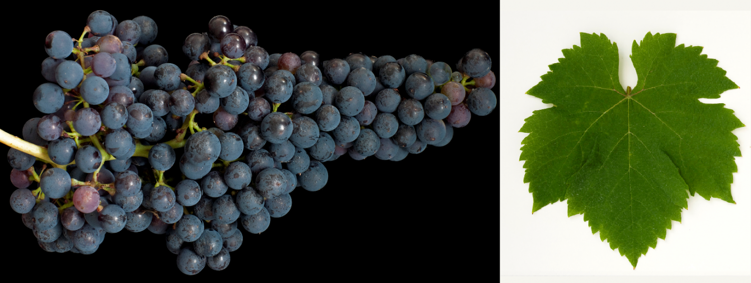
A special note about the Italian language– The word, “OltrePò” has a simple meaning of “over the Po” which simply defines where it is found. The wine region is over the Po in the hills around the City of Pavia – thus the name OltrePò Pavese. The accent on the word means that the O at the end is emphasized in the pronunciation.

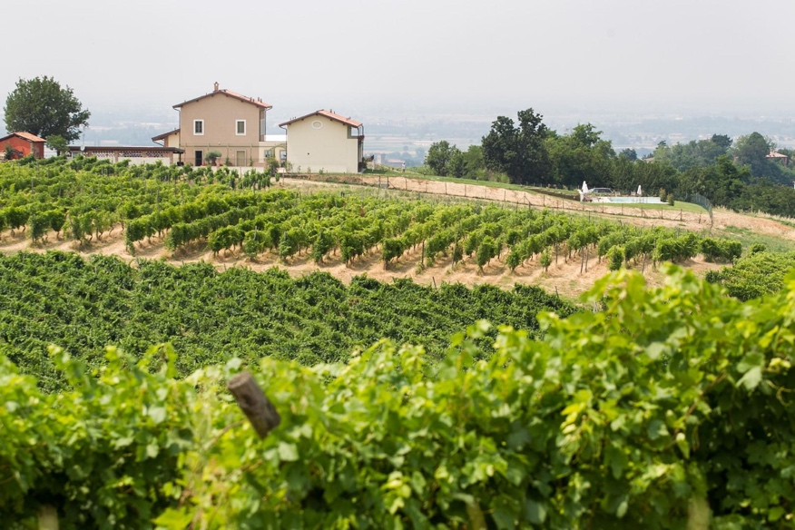
Croatina is the primary indigenous grape in this region and a red wine in the DOC or Bonarda Dell’Oltrepò Pavese is made with at least 85% Croatina. In other words, they are varietal blends of the Croatina varietal and can be blended with Barbara, Uva Rara or Vespolina. Within the wine laws of the DOC, there are no aging requirements nut there are the normal minimums for Alcohol such as 9% for frizzante versions and 12% for Rosso Tranquillo – a still wine.

Croatina is an ancient varietal that is said to have originated in this region and is highly resistant to mildew that can affect other varietals. It is most widely planted in Lombardia but appears in Emilia Romagna as a blending grape. Croatina is also known as Bonarda in some areas and thus the wine takes that name. However, it is not the same as a bonarda grape that can be found in Piemonte.

The Oltrepò region is also known for the plantings of Pinot Nero and both varietals enjoy the microclimate of the Po river that allows for the high altitude, steep slopes with warming effects from the plains and river. The wines are vinified in both stainless steel with frizzante versions made with the charmat method.

The wines are fruity with minor floral notes and medium spice. Medium to light body with relatively rustic tannins and flavors of cherry, blackberry and black pepper. Medium to medium plus in intensity, these wines offer an interesting and somewhat complex wine that marries well with pasta, lasagna, salumi, pork and grilled meats.

The Uva Rara grape adds the spice to the wine and the local area is said to add spice to Lombardia from a viticultural perspective. In addition to the Bonarda, many of Italy’s best pinot noirs and sparkling wines from this region.

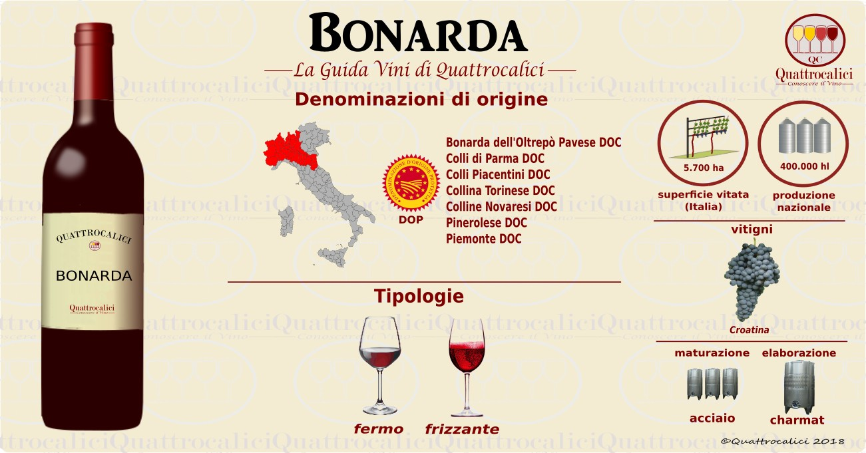
A presto.

