CARMIGNANO DOCG

Ciao a Tutti! Hello everyone.
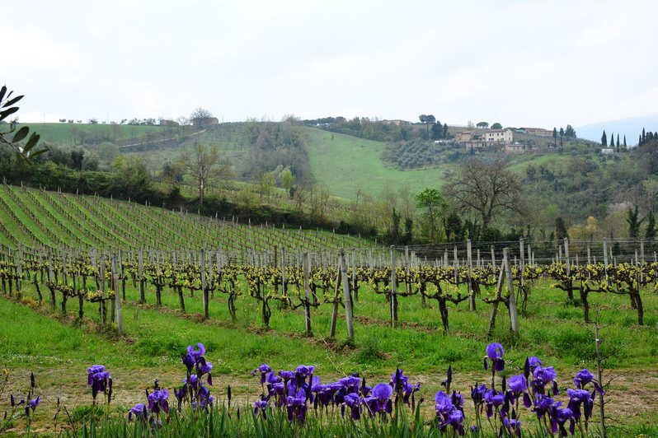
Today, we will be discussing a wine that most are familiar with but with a small twist. Sangiovese and Chianti is an ancient wine, said to be vinified by the Etruscans themselves. The very people that are credited with the advent of wine in Italy. Etruscan ruins are being unearthed all over Italy and with them are clay pots and other evidence of their wine making. Today, we are discussing the Carmignano region of Tuscany, one of the subzones of Chianti, that is just to the west of Florence.

The entire Carmignano zone lies within a relatively small region, consisting of the Carmignano and Poggio a Caiano Communes in the Tuscan province of Prato. The zone is dominated in history by the family owned Capezzana Estate which was instrumental in establishing this zone as a DOCG region. The wines here are regulated to contain at least 50% Sangiovese and allow for up to 20% Cabernet Sauvignon or Cabernet Franc and with the potential for additional black and white varietals added to the blend. Canaiolo Nero, Canaiolo Bianco, Trebbiano or Malvasia are common blending options. Carmignano offers a Rosso and Riserva version with aging requirements for both. The Rosso ages 20 months with 8 in barrel while the Reserva is extended to 3 years and 12 in barrel.

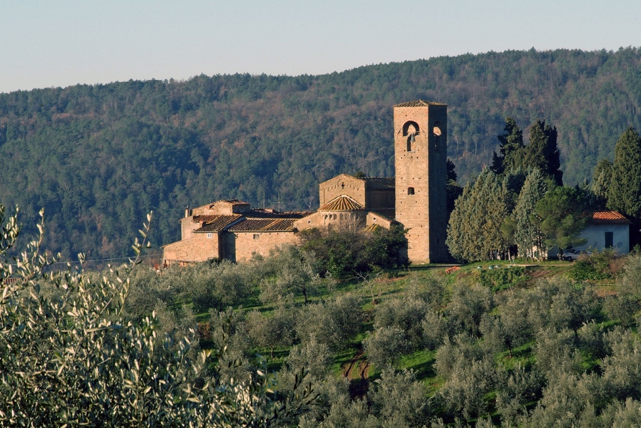
After the Etruscans, the wines of Carmignano are said to have been well known in the Roman era and well established in the Renaissance.

Much of the history is captured on vases in the tombs and writings of Caesar himself speaking of these wines with his veteran army from 50-60 A.C..

Catherine de Medici, the queen of France in the mid-1500s is credited with introducing Cabernet Sauvignon to the region and this unique blend was a very different wine from the rest of Tuscany. Carmignano was one of the earliest protected wine zones along with Chianti itself but was later integrated into the Montalbano subzone until becoming an DOC in 1975 and a DOCG in 1991. Overall, Carmignano can be known for its uniqueness well before the Super Tuscan movement in the late 1900s.

Carmignano offers other wines, such as a Rosato and a Vin Santo but those wines do not fall under the DOCG wine laws but rather are controlled as separate DOC denominations. The DOC name was changed to Barco Reale di Carmignano and the Vin Santo di Carmignano DOC is also distinguished with the Carmignano name added at the end. The Rosato blends are the same but the Carmignano DOCG receives the best of the best grapes and the most attention.

The wines typically have more extraction and color and the blends offer beautiful structure and age-ability. They are receptive to wood aging and offer hints of vanilla, almonds, coffee as well as traditional Sangiovese fruit flavors and aromas. The wines I have tried have had excellent balance in the acid and a long, somewhat hot finish.

A presto.

