Erbaluce di Caluso of Piemonte

Ciao a Tutti! Hello everyone.
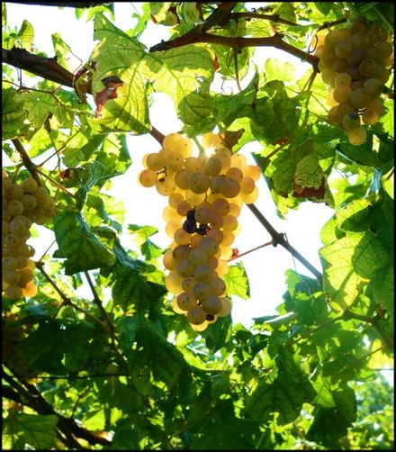
Today, we will be discussing a DOCG wine region of Italy that is lesser known when compared to its neighboring production regions. The discussion for today focuses on the White Grape Erbaluce and the Erbaluce di Caluso DOCG of Piemonte. The wines are made in still, spumante and passito versions and are wonderful wines to enjoy before a meal. They marry well with antipasti and fish, calamari and artichokes.

Erbaluce – a combination of the words for herb and light… Is an ancient varietal that was referred to as Alba Lux (dawn light) and was first harvested in Piemonte. Some experts believe that it is a clone or derivative of Fiano but the majority of research suggests the grape is native to the area. It has high acidity and its fragrant nature lends itself to both still and sparkling applications.

The dry versions are pale gold in color and exhibit aromas and flavors of wildflowers and hay. Looking up the Italian descriptions, they refer to “Biancospino and Gelsomino” as classic aromas of hawthorn and jasmine. The fruit driven and floral notes are the principal indicator of this medium bodied wine of moderate plus intensity. There can often be honey and citrus notes underlying the finish.

Erbaluce is the sole grape of the DOCG region that bears its name and it is a small region surrounding the town of Caluso in the northern half of Piemonte. The wines are refreshing and meant to be drunk young. Erbaluce is also the primary grape of Canavese Bianco, which is cultivated in the Torino area and is a lower alcohol, dry wine. In the DOCG region, all three versions of the wine are 100% Erbaluce.

Caluso Passito is a luxurious sweet wine of distinction and may be the area’s best known product. The grapes are dried after harvest until the February or March timeframe and fermentation requires another month. Aged in oak for three-four years, the passito sweet wine is full-bodied and velvety. The riserva passito requires the four years.

The Spumante wine is, as stated earlier, 100% erbaluce grape and sits on the lees for 15 months. About 20% of the wine production is sparkling, made in the metodo classico technique. The wine thickens in texture over time to balance the high acidity and displays orchard fruits and honey on the palate.

In most cases, wines of this class can be found in the low $20 range and offer a unique wine for your next party.

A presto.

