Fiano di Avellino DOCG

Ciao a Tutti! Hello everyone.

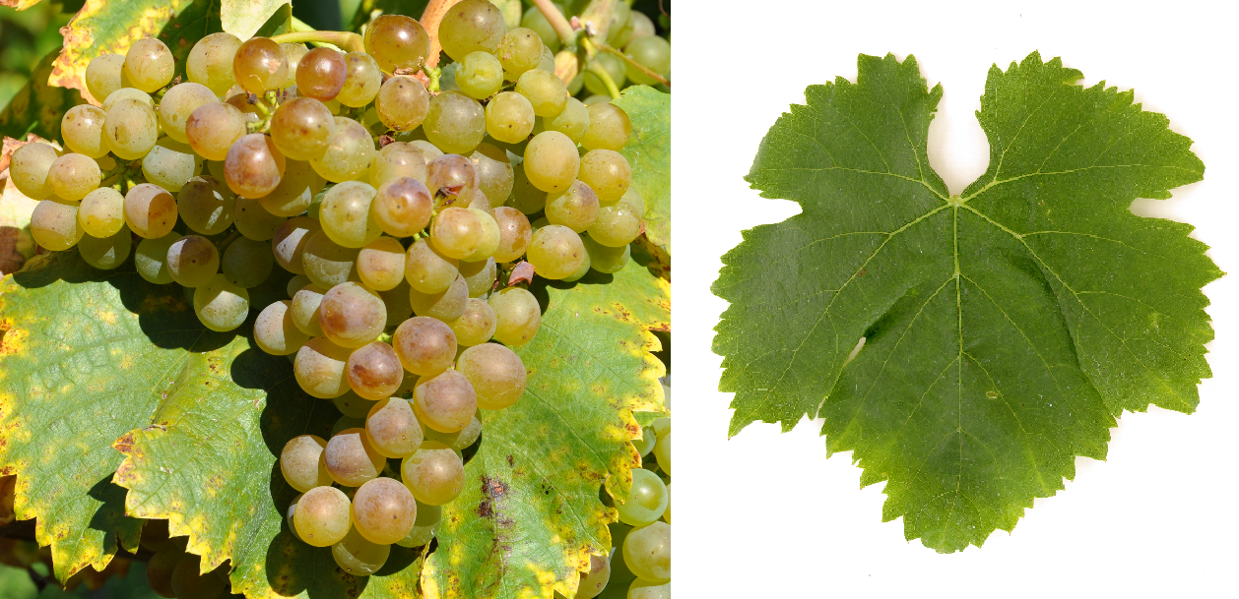
Today, we will be discussing a wine and its associated DOCG production zone in Campania, a Southern Italian Province known for several classic wines, including Aglianico and Greco di Tufo. Fiano is a white grape that is said to have originated in the hills east of Avellino. It has a viable structure that allows for some age worthiness as well as for drying and used in Passito wines (such as in the Irpinia DOC). Like many other indigenous wines, Fiano almost went extinct in the 1970s but has made a comeback and today enjoys a stable return to the area of its origins in the DOCG region of Fiano di Avellino.

Dr. Antonio Mastroberandino brought this wine back with his love of viticultural history. Within the wine laws of the Avellino DOCG, some trebbiano, Coda di Volpe or Greco may be added to the varietal blends of at least 85% Fiano. There are no age requirements and the name Apianum may appear on the bottle – an ancient name for the area.

Fiano plays a part in other DOP regions such as:

- Brindisi DOC
- Molise DOC
- Salice Salentino DOC
- Sannio Fiano DOC
- Sicilia DOC
- Sqinzano DOC
- Among others

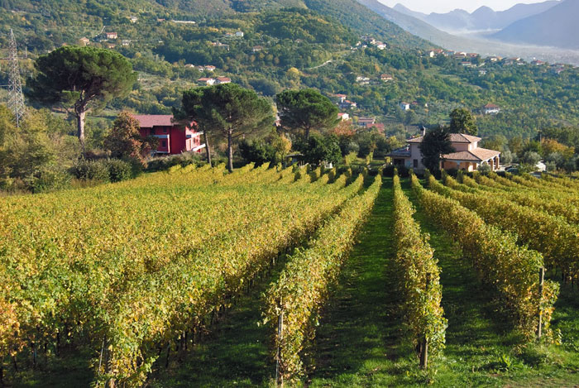
It can be found in still, frizzante and spumante versions in these other DOCs but the Fiano di Avellino DOCG produces only still white wines. The white wine is fruity and floral with moderate intensity and some complexity on the finish. It marries well with antipasti, local soups, and fish-based meals. It has moderately high acidity and is typically light to medium bodied. The most common characteristics of Fiano di Avellino wines are the aromas of peach, pineapple and golden apple with a underlying structure of tropical fruit acidity and green tea notes. It grows best in volcanic soils.

Good examples of a Fiano di Avellino can be found in most big city markets for around $20.
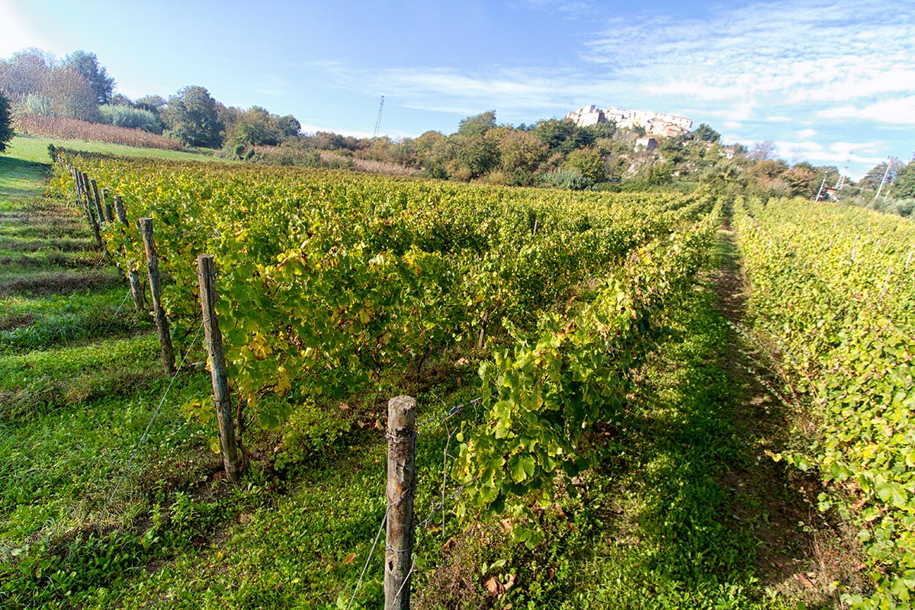
Fiano wine is very versatile in that it works both slightly acidic (e.g., tomato-based) and savory (e.g. cheese, butter) dishes. While in Italy it commonly is used with fish and shellfish, it also goes well with chicken, pork and veal with any sauces that are not strongly citrusy

A presto.

