Freisa

Ciao a Tutti! Hello everyone.

Today, we are back in Piemonte to discuss another fine wine of the area. Most people associate the region with Nebbiolo, Barbera, Dolcetto and Moscato based wines but at one point in history, Freisa was one of the most important grapes of the region and was widely planted in Lombardia and the Veneto as well. Today it is mostly planted in and around the Asti region and is primarily produced in two DOC production zones.

Freisa di Chieri DOC
Freisa d’Asti DOC.

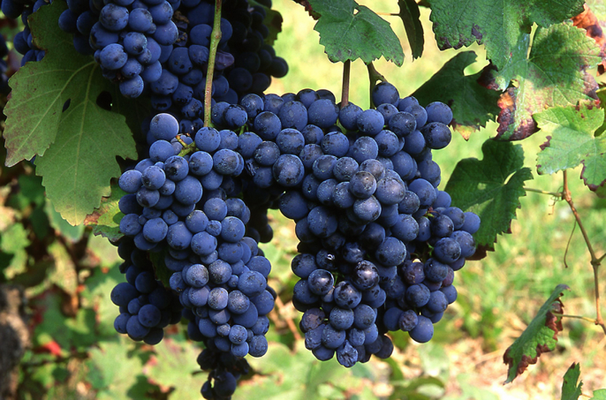
Freisa is also special as it is either the parent or the child of Nebbiolo. Numerous DNA studies have established the relationship but cannot determine which came first. More than 80% of Friesa DNA is identical to Nebbiolo from which Barolo and Barbaresco are produced.

Similar to its relative, Freisa grapes are packed with tannins and must be handled with care in the vineyard and the cantina. The warmer climate from global warming is doing a favor for Friesa in that it is calming the tannins a bit and thus the wine is growing in popularity.

The commercially available Freisa wines are fresh, lively and dry reds that are matured in steel and show a naturally high tannic structure and acidity, medium body and medium alcohol. The flavors tend to strawberry, sandalwood, earth, plum, violet, and raspberry. Normally paired with pasta and local meats, the wine also marries well with grilled and fresh vegetables.
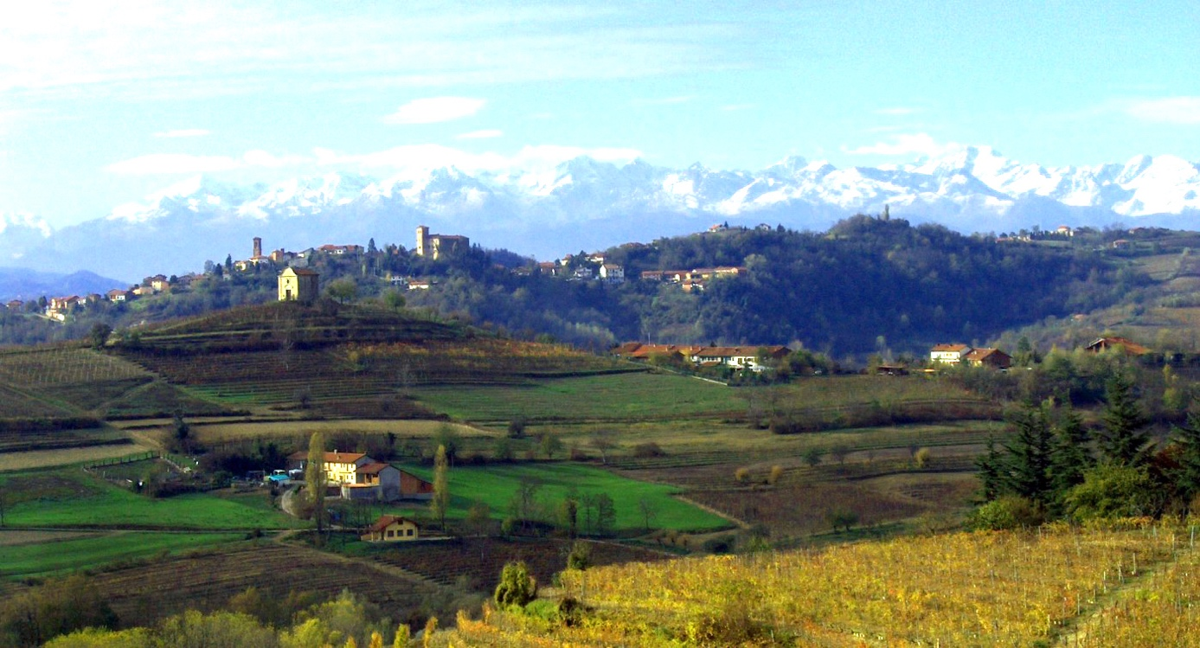
The primary difference between the DOC regions is the level of Freisa required but both are varietal blends, higher than 85%. Chieri requires the lower level of 90% and produces Rosso, Superiore and Spumante versions of the wine. The superior ages for at least a year with 6 months in the barrel. Asti requires 100% Freisa and produces the same versions with the same aging requirement for time but no requirement for time in barrel. In both cases, the spumante wines are produced at variable levels of sweetness.

After a quick search for market prices, this wine can be found for around $20.

A presto.

