Marsala DOC

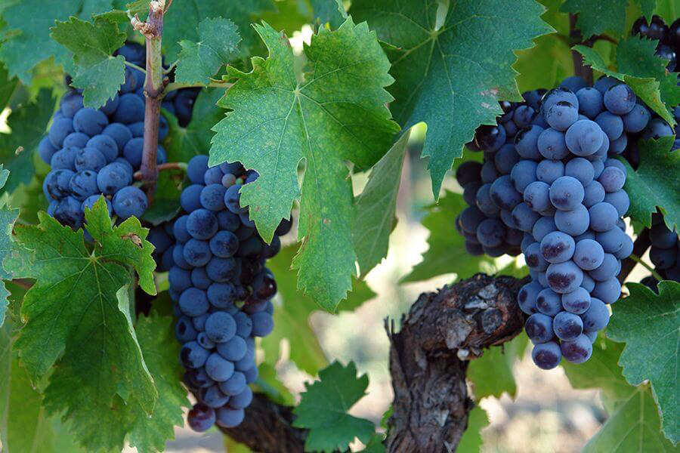Ciao a Tutti! Hello everyone.

Italy is essentially a foot kicking a soccer ball. No wonder soccer is so famous there. The soccer ball – oh that is Sicily or Sicilia in Italian. Just off the island is a very small island named Pantelleria. On the far western edge of Sicilia is the Marsala DOC which shares some common focus with the Pantelleria DOC when it comes to Dessert and Specialty wines. Today we will focus on Marsala.

Marsala DOC produces wines from multiple black and white grape varietals including Ansonica, Catarrato, Grillo, Nerello Mascelese, Nero D’Avola and Perricone. Unlike the rest of Sicilia, this zone produces dessert and specialty wines of different types, colors and blends. The wines are sold as Amber, Gold and Rubino versions with greater than 17.5% potential alcohol. They are aged depending on their level of quality from one year for Fine versions to 4, 5 and even 10 years for Vergine Stravecchio wines.

In 1773, an Englishman named John Woodhouse arrived at the port of Marsala where he tried the local wines and he noticed it to be very similar to Port – the Spanish wines he had tried on earlier stops in that country. As a sailor, he was dependent on the products of the port towns and he exported these wines to England. He carried barrels of the wines on his ships to continue the aging process as the people of Marsala did it. It was a success and the wines are known today around the world, made in much the same way.

The wines and tourism form the economic base of this area and a good Marsala can be found in most wine shops for around $10 if you want to make Chicken Marsala tonight.

A presto.

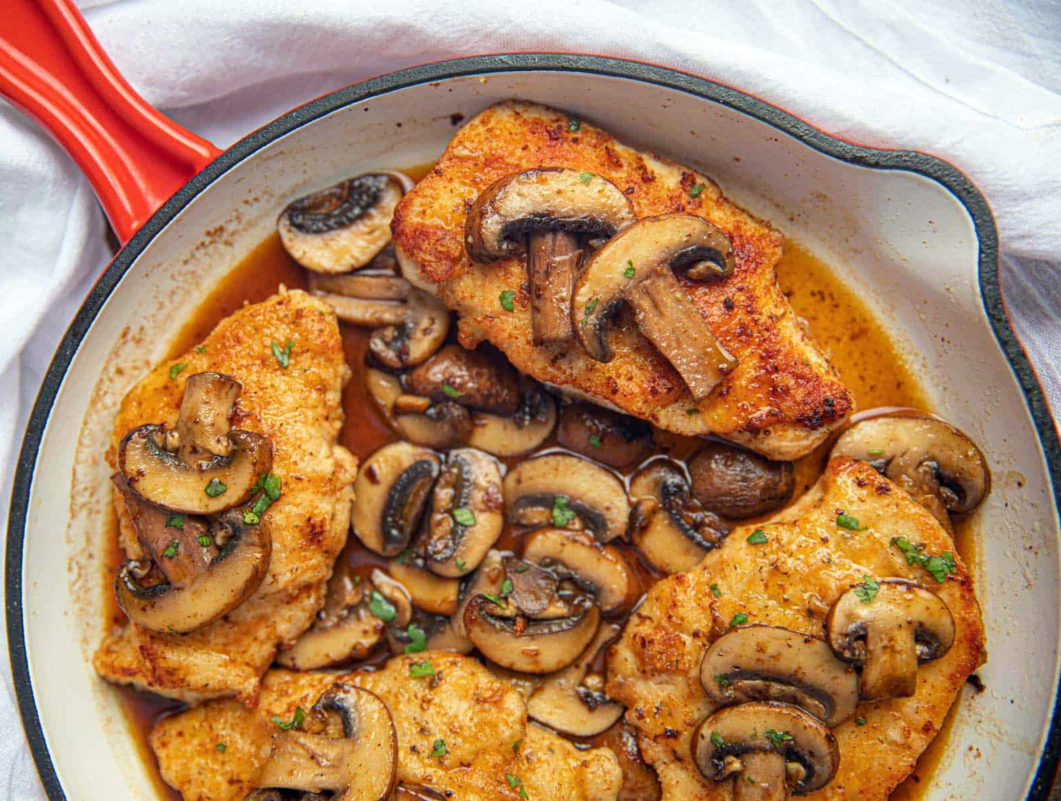

An Italian Recipe for Chicken Marsala

Il petto di pollo al marsala sono un ottimo secondo piatto da preparare e servire se si hanno invitati. Un modo diverso per servire le fettine di pollo, donandogli un gusto davvero unico.

Il sapore dolce del marsala le insaporirà tantissimo dandogli un sapore dolciastro molto gradevole al palato. Anche i bambini impazziranno per la loro bontà. Molto veloci da preparare, si accompagnano bene con diversi contorni, sia di verdure che di patate. Servendo entrambi i contorni potrete creare un piatto unico molto ricco e invitante.

Ingredienti
3 fette di pollo
1 spicchio di burro
3 cucchiai di olio extravergine d’oliva
100 ml di marsala
q.b di sale
q.b di farina 00

Preparation
La preparazione di queste fettine di petto di pollo al marsala è velocissima.

In una padella mettete l’olio e il burro. Accendete il fuoco e fate fondere il burro a fiamma bassa, stando attenti a girarlo spesso così da non bruciarlo.

Se vi piacciono potete usare anche le sottilissime che già pronte,valtrimenti se vi sono uscite grosse potete schiacciarle un pochino usando il batticarne. Mettete un po’ di farina in un piatto. Infarinate le fettine da tutte e due le parti schiacciando bene, poi sbattetele un pochino per eliminare la farina in eccesso. Quando il burro si sarà sciolto completamente versate dentro le fettine.

Fate cuocere da entrambi i lati fino a quando non saranno ben dorati. Aggiungete il marsala e fatelo evaporare a fiamma alta. Dovrà caramellare un po’ creando una crema un dolce e densa. Servite nel piatto con la sua crema di cottura accompagnando le fettine con un’insalata.

In alternativa potete preparare delle scaloppine al limone o delle scaloppine alla pizzaiola.

An Italian Recipe for Chicken Marsala

Marsala chicken breasts are an excellent second course to prepare and serve for your friends. This recipe offers a different way to serve the meal, giving them a truly unique flavor.

The sweet taste of marsala will flavor them a lot giving it a sweet taste very pleasant on the palate. Even children will go crazy for their goodness. The meal is easy and quick to prepare, and it goes well with other side dishes, both vegetables and potatoes. By serving both sides you can create a very rich and inviting single dish.

Ingredients
3 slices of chicken
1 clove of butter
3 tablespoons of extra virgin olive oil
100 ml of marsala
salt to taste
q.b of flour 00

Preparation

The preparation of these slices of chicken breast with marsala is very fast.

In a pan put the oil and butter. Turn on the heat and melt the butter on a low flame, being careful to turn it often so as not to burn it.

If you like you can also use the very thin ones that are ready, otherwise if there are large outputs you can crush them a little using the meat tenderizer. Put some flour on a plate. Flour the slices on both sides by squeezing them well, then beat them a little to remove excess flour. When the butter has melted completely pour into the slices.

Cook on both sides until they are golden brown. Add the marsala and let it evaporate over high heat. It will have to caramelize a little, creating a cream that is sweet and thick. Serve on the plate with its cooking cream accompanying the slices with a salad.

Alternatively, you can prepare lemon escalopes or pizzaiola escalopes.

