Orvieto DOCG

Ciao a Tutti! Hello everyone.

Have you ever heard of Orvieto wines? No? It is not like Italy has the normal names that we are used to internationally. Sure, they have merlot and cabernet sauvignon, Chardonnay and Pinot Noir – even though they call it Pinot Nero but many Italian wines go without much interest in the United States because they are not known or can be difficult to pronounce. Italy has thousands of grape varietals and at least 80 important ones that cover the 20 political regions. Orvieto is the DOC (the area designation that also controls wine characteristics) and wine name and is made from Grecchetto and/or Trebbiano grapes.

In the region of Umbria, there are two really important wines – one red and one white and today we are talking about the white grape of the region.

The white wine is called Orvieto and it is grown in a region that borders and shares land with Lazio, the region of Italy where Rome is located. As we mentioned, Orvieto is made from Grecchetto and Trebbiano - at a minimum of 60% with other approved white grapes added.

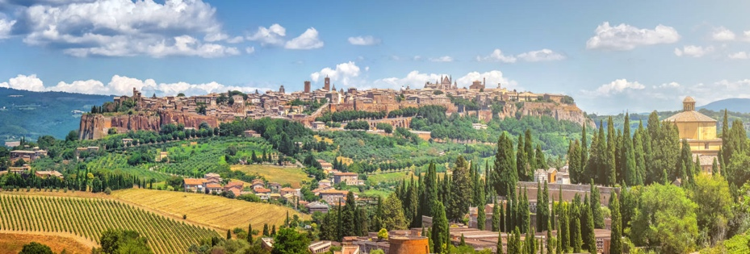
There are Bianco and Superiore verions with a 5 month age regulation for Superiore. They also produce two types of dessert wines – Muffa Nobile and Vendemmia Tardiva – Wines made from late harvest grapes and some that contain Botrytis or Noble Rot. The semi-sweet version is called Orvieto Abboccato. I once referred to this wine with an Italian from northern Italy and he told me he had never heard the word and thought I had said Avvocato – Lawyer in Italian. It’s a real word and a real wine but I guess they don’t use the term in Piemonte.

The noted Physicist Enrico Fermi toasted the first successful nuclear reactor with a glass of Orvieto wine. The wine is clear and light white in color and can suffer from overproduction. Classico wines, from the Classico area of Orvieto, are typically more consistent in quality and show great minerality and depth of character. After 2003, the trend has been moving to Grecchetto rather than the less flavorful Trebbiano in the better showing wines.

Grecchetto is the grape that provides the backbone of fruitiness and weight to Orvieto and the dry wines of today are far different than the historical wines of the region. Umbria is a region that was under the great influence of the Etruscans, and Romans and has been making wines from Grecchetto and Trebbiano since the middle ages. The transition from sweet wines to the more finessed and dry wines of today, take advantage of the flexibility of these white grapes and in particular, Grecchetto. As with much of Italy, grapes that can be made in different styles – usually are and that is no exception here.

A presto.
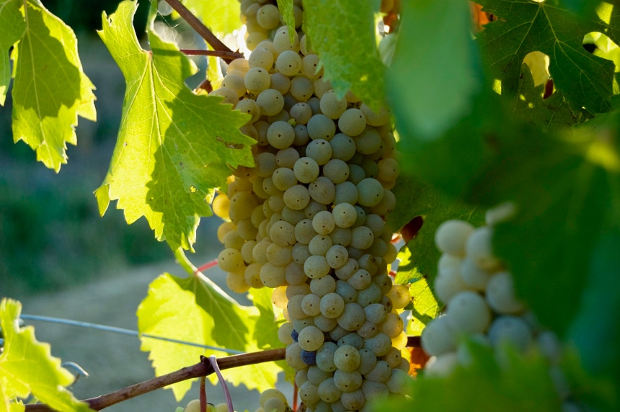
Grecchetto:

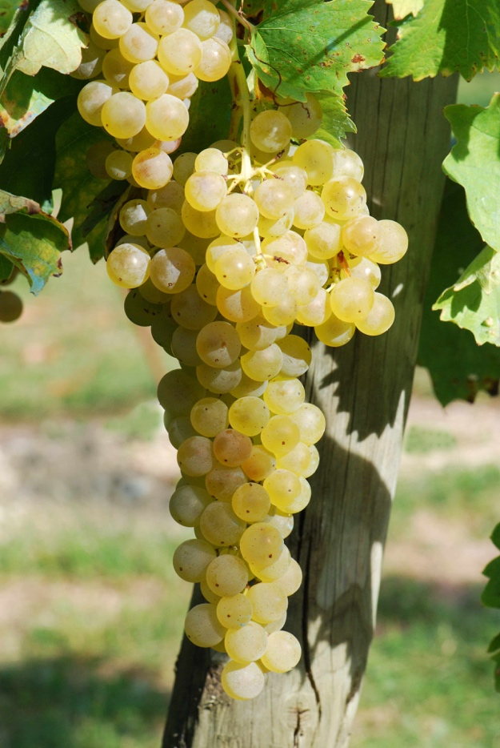
Trebbiano:

A curious thing – Trebbiano is also known as Ugni Blanc -a grape grown in Southwest France and widely used in Cognac and Armagnac.

