Rosso Piceno

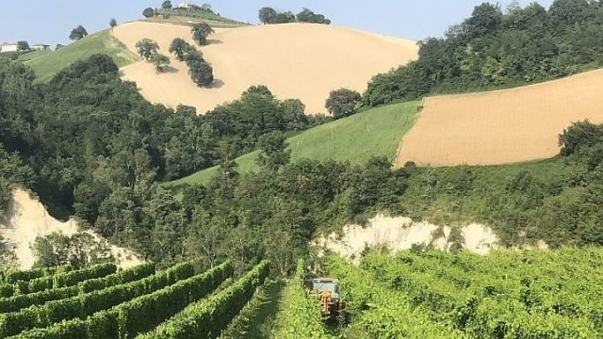
Ciao a Tutti! Hello everyone.

Today, we will be going to the Italian Region of La Marche… The Italians say that one can find all of Italy in one region as it has beaches, mountains, walled cities, history, art, food and wine that is indicative of the Old Country – all in one place.

La Marche is also the bridge between the regions where Montepulciano and Sangiovese varietals dominate in Italy and is a land that produces both. La Marche is the where the two great red grapes of Italy come together on the Adriatic Coast and meet in the middle of the Peninsula. The Rosso Piceno or just Piceno DOC region is where these two grapes are used to produce red wines of quality and distinction.

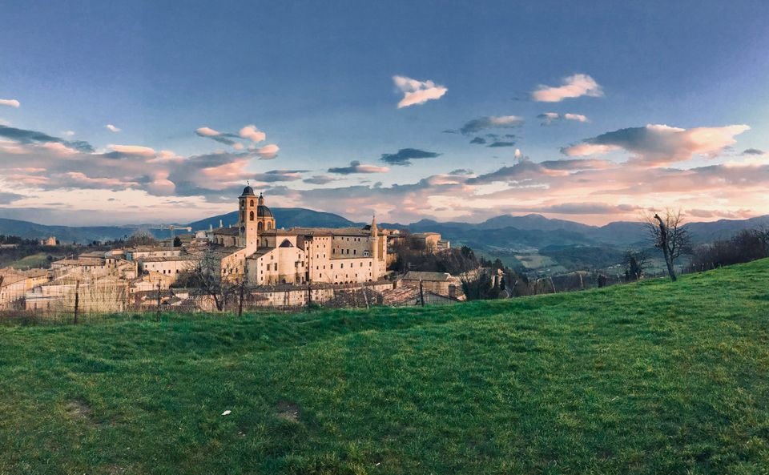
Rosso Piceno was established as a DOC in 1968 (the first DOC of Marche) and produces reds that combine the two grapes in various combinations. The base red wine can contain 35-85% Montepulciano and from 15% to 50% Sangiovese with other approved grapes thrown in. The region also produces a varietal Sangiovese wine – that means at least 85% Sangiovese is in the wine. Superiore wines are more rare and are produced in only 13 of the most southern towns that are stated to be perfect for grapevine cultivation. They require a year of age to gain the Superiore on the label.

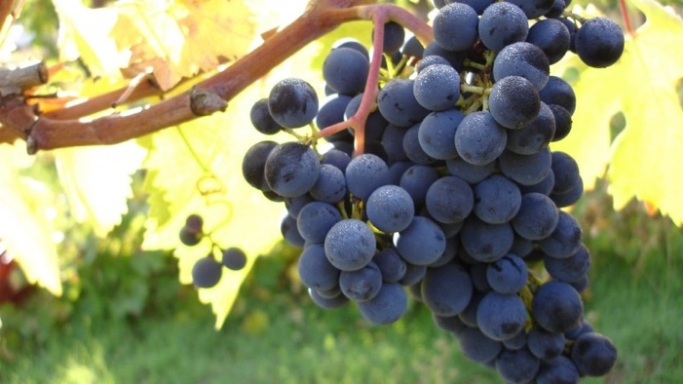
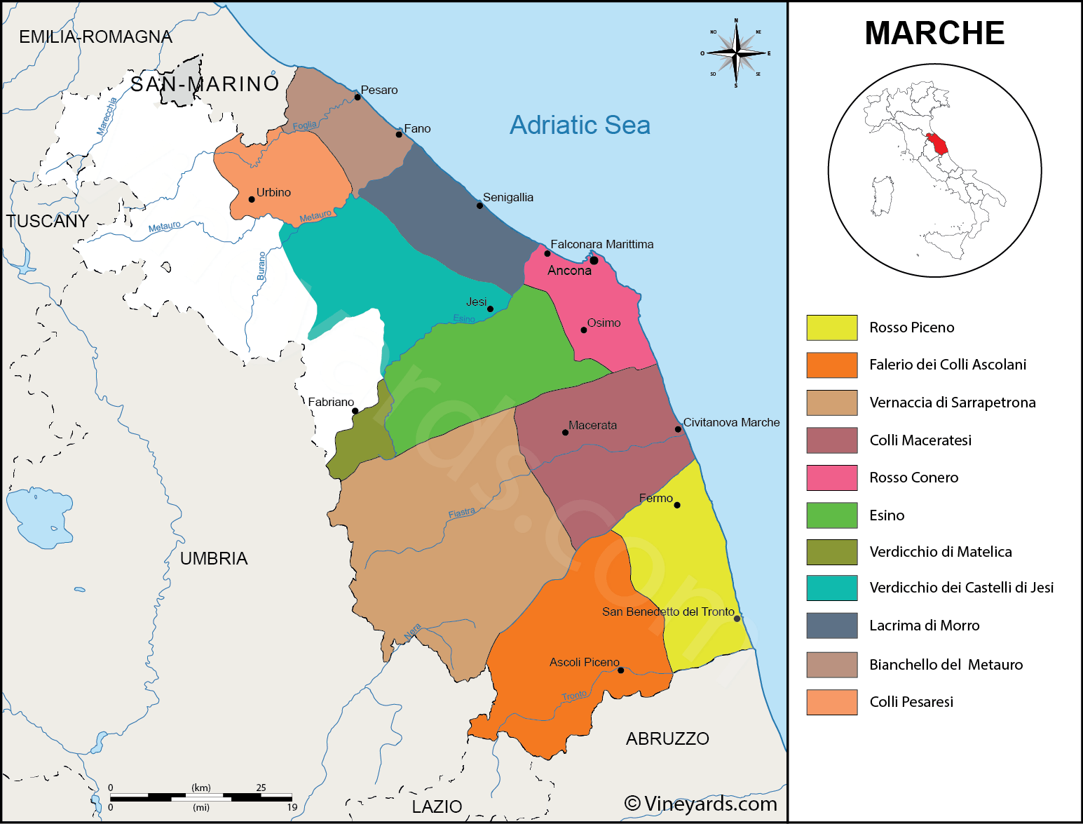
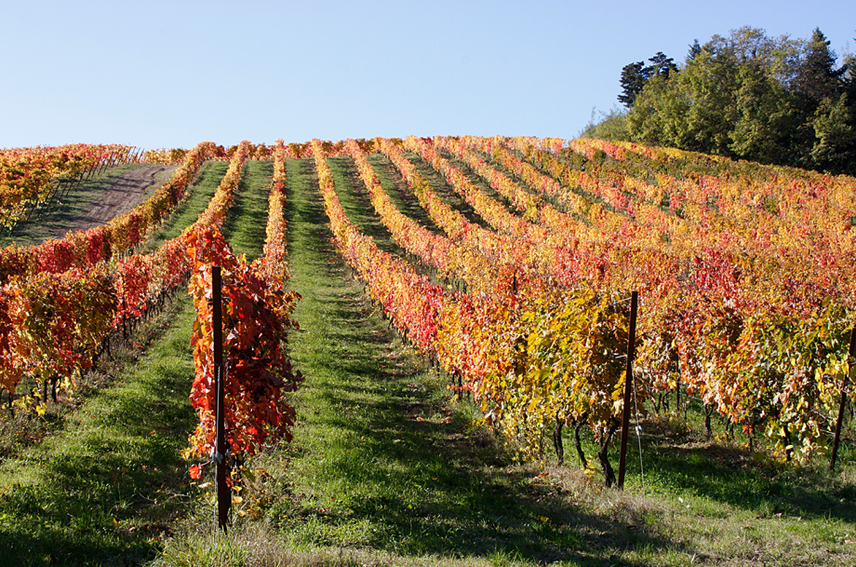
The Rosso, Novello, and Sangiovese wines are produced for drinking with local food and are typically drunk young. Historically, Marche lagged behind Tuscany and Umbria in terms of reputation but the Rosso Piceno wines have improved and now stand up to the wines of those regions. Marche enjoys a temperate climate and hillside vineyards that fit well with both varietals. The area is rather large and covers the provinces of Macerata, Fermo, Ascoli Piceno and Ancona.

The combination of clayish soils, perfect weather conditions, low rain levels and hillside locations, a Piceno Rosso wine is worth finding. They are on the lower end of price and can easily be found for around $15. They typically are well balanced with fruit concentration and medium + acid – making it a good combination for Italian pastas, pizza or American food.

A Presto

