Salice Salentino DOC

Ciao a Tutti! Hello everyone.

In the heel of the boot of Italy lies Puglia. One of the largest wine producing regions of the country but with far less below the DOP level than at DOC/G quality standards. Puglia is a wine region that produces roughly the same amount of red and white grapes and was well known in the past to export much of their production for table wines in the more central and northern regions. Today, Puglia is like many of the other southern regions of Italy in that it is producing higher quality wines at the DOP level and improving their methods and quality continuously.
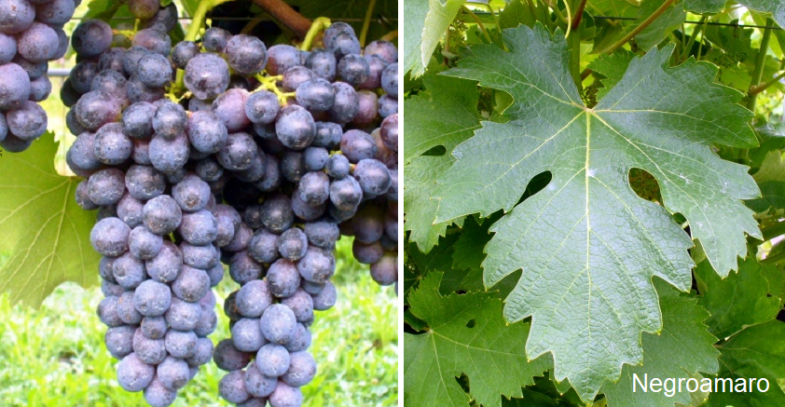
Among the fine wines of Puglia is Negroamaro – translated to black and bitter – this grape and wine is far from that as it produces round, full and delicious wines. Negroamaro was likely brought by the Greeks to Italy but others believe it is indigenous to Puglia. Either way, it is considered to be the most important grape of the region and is a major component of the DOC zones. Salice Salentino DOC is the leading DOC zone for Negroamaro.

The wines are deep in color, usually dark ruby with black highlights. The flavors and aromas can include accents of apples, pears, plums and prunes as well as rich red fruits. The rounds are soft and round on the palate and one can find them with flavors of watermelon – a rare and unusual flavor profile that pairs well with rich meat dishes, meaty pastas or roasted duck.
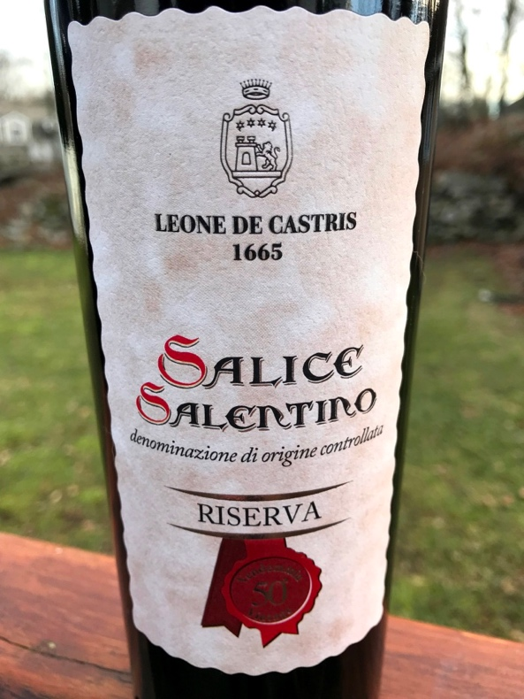
Salice Salento does produce more than Negroamaro based wines and focuses on several white varietals as well as Aleatico in the black grape family. Chardonnay, Fiano and Pinot Bianco are easily found in the zone and are usually made as varietal blends in white, rosato, red, sparkling and sweet wines. The Rosso wines are based on Negroamaro and a Negroamaro varietal blend leads the red wines in reputation. Negroamaro also forms the basis for the rosato wines of the DOC. Sparking versions are either white or made from the same rosato blend.

The grapes in Salice Salentino go through a stage of drying or appassimento before pressing. This intensifies the flavors, alcohol levels and intensity of the wines – typical of the Italian South. The appassimento technique is used all over Italy and concentrates the sugars as water evaporates from the grapes, resulting in higher alcohol wines for those taken to full fermentation or sweet wines if the sugar levels are allowed to elevate so high as to stop the fermentation before it is complete. This leaves “residual sugar” and therefore sweeter wines.

Aging of these wines depend on the type of wine that is being pursued. The higher quality grapes are used in the Reserve wines and can see the usual 2 year aging process in wood and bottle. This is true in the case of Aleatico and Negroamaro Riserva wines.
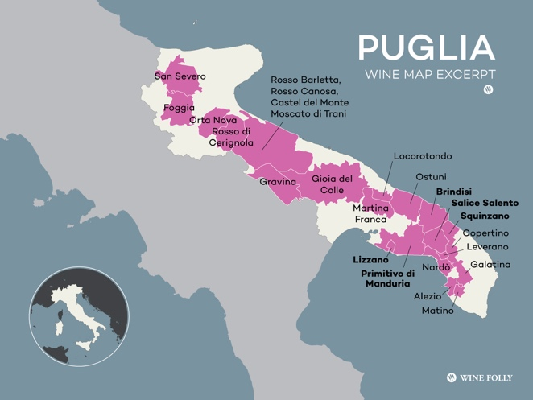
In my experience, I find Negroamaro riserva wines in the US market that are a great bargain and worth every effort. I encourage you to pick one up and enjoy it with a meat-based pasta. And check my “Wines of the Day” section because I tasted and evaluated one recently.

A presto.

