Valpolicella

Ciao a Tutti! Hello everyone.

Today, we will be discussing another of the great Italian wines that is made in a very unique form and results in various types of wines, depending on the exact timing of the process. The grape is Corvina – at the base of the wine at least, and the wine we will start with is Valpollicella.

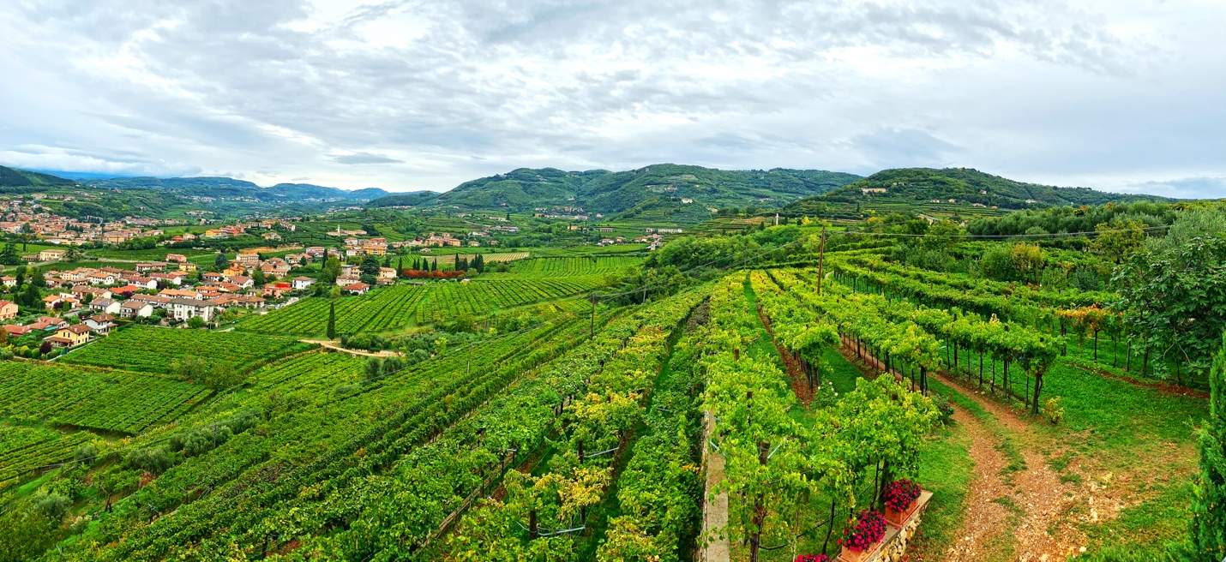
Corvina seems to express itself best in the hillsides that form the Bardolino and Valpolicella zones in the region of the Veneto. Valpolicella is found to the east of Lake Garda in the Bardolino zone. The area is complete with vineyards surrounding the city of Verona. The zone extends from the Lessini mountains in the north to the Veronese plain and overlaps with the Soave zone to the east.

Well before Amarone wine rose to be considered one of the top luxury wines of Italy, Valpolicella wine was the mainstay of the area. It is a simple yet refreshing wine but did not aspire to be any more than a table wine to go with Gnocchi or other local dishes. After Amarone rose to significance, the producers of Valpolicella decided to add muscle to the wine, improve the quality and work it into the international market.

Valpolicella is made from the same grapes that as Amarone but it is processed in a more traditional vinification method and may retain some residual sugar (maximum of 0.4% potential alcohol). The required grapes are:

- 45-95% Corvina
- 5-30% Rondinella
- Max 25% other approved grapes. Molinara is used in small amounts (sometimes) to add lean acidity

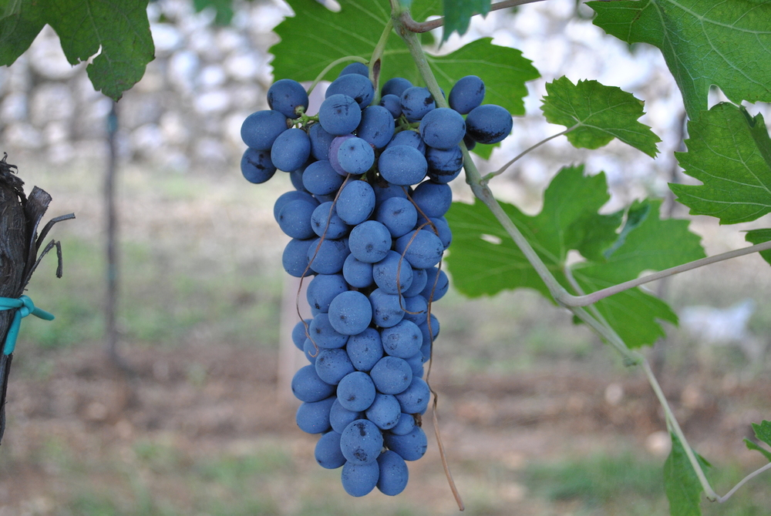
Amarone is made by drying the grapes for a few months on mats in a process called “appassimento” and the wine is fermented to dryness. Amarone results in a deep, rich, hich alcohol wine with developed fruit flavors while Valpolicella is a fresh and approachable wine from the start - bright, lively and balanced with flavors of savory but sour cherry.. Two very different treatments from the same area (and there are others – Ripasso and Ricioto – discussed briefly later). Valpolicela wine is made in a Rosso and Superiore style with an age requirement of one year for the Superiore.

The entire Veneto region is third in overall red wine production behind Chianti and Montepulciano d’Abruzzo for all of Italy. Some believe that the name of Veneto is blend of Greek and Latin names that translates into “Valley of many cellars”. Within a single visit it is easy to agree with the possibility.

The Recioto style of sparkling and dessert wines are made with the appassimento approach but with residual sugar of 2.8% minimum potential alcohol and Ripasso red wines are made when Valpolicella is blended with still fermenting Amarone grapes for rounder and deeper flavor profiles. The four styles of wines (these and Valpoicella and Amarone) are each unique and represent this unique region of northern Italy.

A presto.

